4th problem screen shots

1.In case of 22

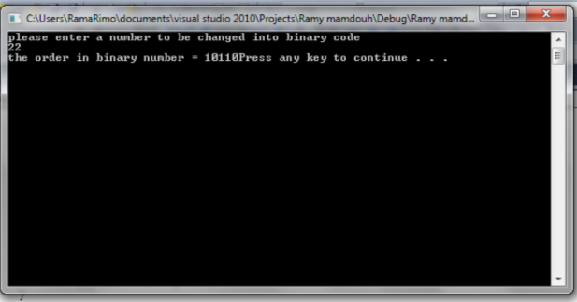

2.In case of 53

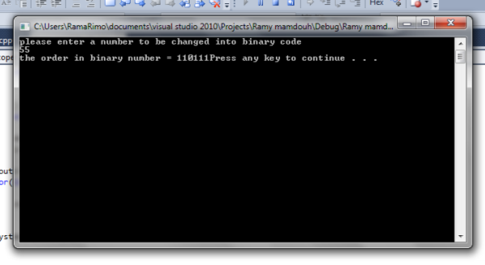

Code:

#include<iostream>

#include<string>

#include<cstdlib>

#include<cmath>

using namespace std ;

int const size = 10; //size of the stack

char thestack[size] ;

int top= -1 ;

bool isfull()

{

if(top==size-1)

{ return true ; }

return false ;

}

bool isempty()

{

if(top==-1)

{

return true ;

}

return false ;

}

int pop() //removing an element from a stack

{

return thestack[top--] ;

}

void push (int element ) //putting a new element in the stack

{

if(!isfull())

{

thestack[++top]=element ;

}

}

void main()

{

int dec ;

int i = 0 ;

cout<<"please enter a number to be changed into binary code"<<endl ;

cin>>dec ; //user entering a number to be checked

while(dec>0) //while the number is bigger than 0 continue doing the calculations

{

if((dec%2)==0)//when the number entered %2=0 then put 0 into the stack

{

push(0) ;

}

else //anything else put 1

push(1) ;

dec=dec/2 ;//at the end of the loop divide decimal number by 2

i++; //to know how many time the loop is being executed

}

cout<<"the order in binary number = " ;

for(int j =0 ; j<i ; j++)

{

cout<<pop(); //removing every element from the stack to show the answer

}

system("pause") ;

}